How We Got the Bible Lesson 5
The Translators and the Preface to the KJV
Who were the King James translators?
Were they saved? Were they educated? Did they think they were making the perfect Bible? What were their goals and motivations for this work?
Queen Elizabeth died in 1603. She did not have an heir, so King James I of Scotland assumed the throne. This was the King James of the KJV.
[Dr. John Reynolds, President of Corpus Christi College,
Oxford, a leader of the Puritans in the Church of England, proposed the
following resolution: “That a translation be made of the whole Bible, as
consonant as can be to the original Hebrew and Greek; and this to be set out
and printed, without any marginal notes, and only to be used in all Churches
of England in time of divine service.” Reynolds felt that a new translation
was needed to replace the Bishops’ Bible, which was then the authorized
version in the Church of England. Reynolds pointed out to the King certain
inaccurate translations and printing errors in the Bishops’ Bible. One of his
examples was Psalm 106:30, which in the Bishops’ Bible read, “then stood
up Phinees and prayed.” Reynolds argued that the Hebrew should be
translated, “Then stood up Phinehas, and executed judgment.”] Emphases mine

King James appreciated this idea for a few personal reasons.
- He disliked the Geneva Bible.
“I profess I could never yet see a Bible well translated in English; but I think that, of all, that of Geneva is the worst. I wish some special pains were taken for a uniform translation, which should be done by the best-learned men in both Universities, then reviewed by the Bishops, presented to the Privy Council, lastly ratified by Royal authority, to be read in the whole Church, and none other.”
- He disliked the notes of the Geneva Bible.
“One of those reasons was its extensive notes. For example, the marginal note in
Exod 1:19 of the Geneva Bible said that the Hebrew midwives were right to
disobey the Egyptian king’s order. Of courses James was opposed to any
suggestion that it was proper for a subject to disobey his king. A note at 2
Chronicles 15:16 suggested that an evil monarch could be worthy of death.”

Richard Bancroft
Richard Bancroft initially opposed the idea of translating. He claimed there would never be any end to translations if every person’s whim were followed. Reluctantly, he ended up being the director of the translation project of the KJV, himself being decidedly Anglican in his theological views, affecting his opinion of certain word choices reflected in the KJV today.
The Translators
There is debate but it seems to be clarified that 47 men actually worked on the King James Version translation.
“3 groups for the OT, 2 groups for the NT, and 1 group for the Apocrypha. When the whole Bible had been translated, it was reviewed by a smaller group of twelve men, two from each of the original six groups. Two men, Miles Smith and Thomas Bilson, supervised the work of the printer, and Smith wrote the preface, “The Translators to the Reader.””
The Translation “Rules”
Written by Bancroft and approved by the King:
- “The Bishops’ Bible is to be followed, and as little altered as the as the truth of the original will permit.”
- Proper names were to be retained in their original language format. “Cain,” not “I brought him.”
- Use church, not congregation. This was due to Anglican theological convictions (convictions, as you recall, that Tyndale did not share and was punished for believing).
- If there is disagreement on a phrase, write what most of the church fathers wrote.
- Don’t change the chapter and verse divisions unless you have to.
- Insert cross references.
- Each group was to translate on their own, and meet together to confer and agree upon what portions would be kept and put in the KJV text.
- When a book is finished, it would be sent to all parties to then be considered “seriously and judiciously.” (Especially by King James)
- As to the previous point, if there is still disagreement, it will be sent back for correction. If there remains dispute, the chief person of each group would confer in a final meeting at the end of the work.
- If there is question due to obscurity of a word or phrase, a national expert of the land/circumstance most closely related to the obscurity would be sent for and consulted.
- The Bishops were to send letters to their clergy requesting men skilled in the languages to report to Westminster, Oxford, or Cambridge.
- Appointed men at each location previously mentioned would direct.
- The translations of these men would be used when they agree better with the original languages than with: Bishop’s, Tyndale, Matthew’s, Coverdale’s, Whitchurch’s (the Great Bible), and the Geneva.
The KJV translators consulted ALL of the versions we have mentioned thus far in our study and more, and used what was written in these versions in multiple instances.
The Translators’ Preface
It is very important that we understand what the KJV translators believed they were doing. They had an excellent translation philosophy.
In the preface to the readers, the translators were aware that their translation would face a great deal of opposition especially from those who saw no need for a new translation in English, so in several statements, primarily at the beginning of the preface, they discuss the problem of hostility to new translations:
(a) “Zeal to promote the common good, whether it be by devising anything ourselves, or revising that which hath been laboured by others, deserveth certainly much respect and esteem, but yet findeth but cold entertainment [reception] in the world. It is welcomed with suspicion instead of love, and with emulation instead of thanks: and if there be any hole left for cavil [trivial objection] to enter, (and cavil, if it do not find a hole, will make one) it is sure to be misconstrued, and in danger to be condemned. This will easily be granted by as many as know story [history], or have any experience. For was there ever any thing projected, that savoured any way of newness or renewing, but the same endured many a storm of gainsaying or opposition?”
(b) “This, and more to this purpose, his Majesty that now reigneth…knew full well, according to the singular wisdom given unto him by God, and the rare learning and experience that he hath attained unto; namely, that whosoever attempteth any thing for the publick, (specially if it pertain to religion, and to the opening and clearing of the word of God) the same setteth himself upon a stage to be glouted [frowned] upon by every evil eye; yea, he casteth himself headlong upon pikes [spears], to be gored by every sharp tongue. For he that meddleth with men’s religion in any part meddleth with their custom, nay, with their freehold [an estate or office held for life]; and though they find no content in that which they have, yet they cannot abide to hear of altering.”
There was a specific widespread objection to their translation that they addressed:
“Many men’s mouths have been open a good while (and yet are not stopped) with speeches about the translation so long in hand, or rather perusals of translations made before: and ask what may be the reason, what the necessity, of the employment. Hath the Church been deceived, say they, all this while?… Was their translation good before? Why do they now mend it? Was it not good? Why then was it obtruded [presented] to the people?”

How did the KJV translators respond to these objections?
- They recognized that all translations (including the KJV), since they are done by fallible men, can be improved. They were “building on the foundation” of the work of others.
- That which is sound, when rubbed and polished, shines that much more brightly! When there is question as to the meaning of a text of scripture, consultation of the original languages (or a dictionary or ability to write someone educated in the field) is at the ready!
- They recognized that translations before them were the Word of God, even if they contained minor errors, because none of these translations were doing the same sort of work – breathed out by God – as the apostles were. The translators of the KJV never claimed divine perfection of their work. [[Previous translators of all the Bible translations hitherto never claimed divine perfection of their work. Modern Bible translators (most) do not claim divine perfection of their work. The Bible translators that Calvary Baptist Church supports do not claim divine perfection of their work! (And yet God’s truth endures to every generation!!)]]
- They believed all previous translations deserved to be used and gleaned from forever, being the same kind of work as their own.
- The believed previous translations, even ones that weren’t very skillful, were the word of God. “Now to the latter we answer, that we do not deny, nay, we affirm and avow, that the very meanest [poorest] translation of the Bible in English set forth by men of our profession (for we have seen none of theirs of the whole Bible as yet) containeth the word of God, nay, is the word of God.”
- For instance, we believe the LXX (The Septuagint we’ve heard so much about!) was the Bible, even though in many cases it wasn’t very skillful.
  - “The translation of the Seventy dissenteth from the Original in many places, neither doth it come near it for perspicuity, gravity, majesty; yet which of the Apostles did condemn it? Condemn it? Nay, they used it, (as it is apparent, and as Saint Hierome [Jerome] and most learned men do confess) which they would not have done, nor by their example of using of it so grace and commend it to the Church, if it had been unworthy the appellation and name of the word of God.”
- The translators believed their work was only part of a continual process of making God’s Word accessibly to the church.
  - Truly, good Christian Reader, we never thought from the beginning that we should need to make a new translation, nor yet to make of a bad one a good one;…but to make a good one better, or out of many good ones one principal good one, not justly to be excepted against; that hath been our endeavour, that our mark.”
- The KJV translators included marginal notes where difficulty and or ambiguity were present.
The King James Bible replaced the Bishops’ Bible as the version authorized for use in the Church of England. Was the Geneva Bible the Word of God? Yes. Was the Bishops’ Bible the Word of God? Yes. Was the 1611 King James Bible the Word of God? Yes.
Was the 1611 Bible the same as the KJV Bibles we have today? No. The KJV underwent many revisions due to typo and translational (not doctrinal) error.
Examples of Change in the King James Version Since 1611

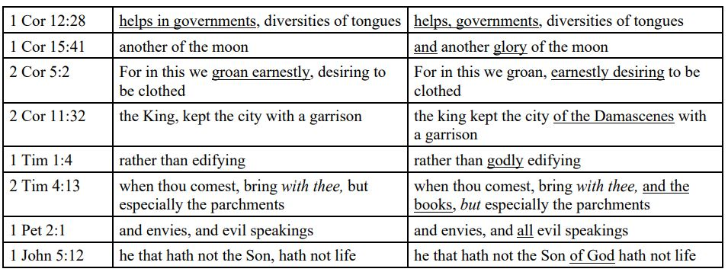
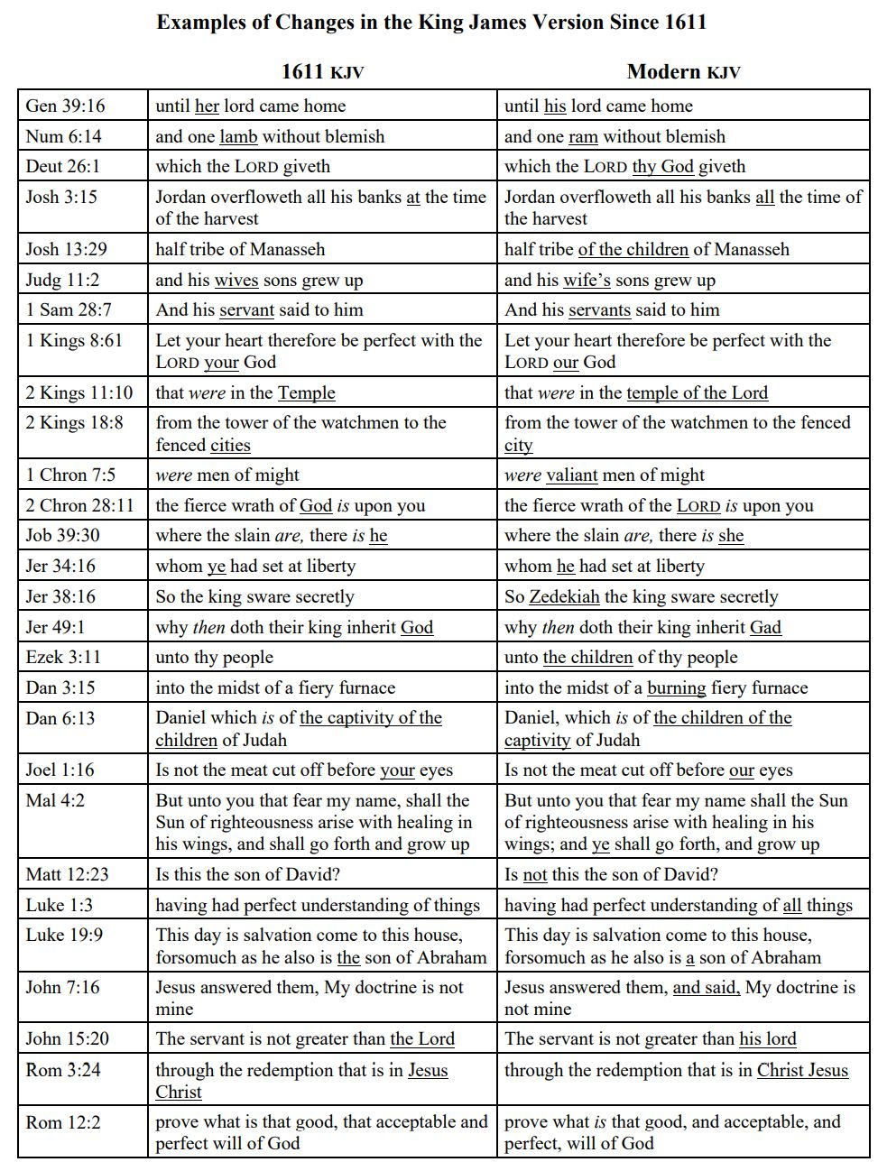 from Dr. Combs notes; see Pastor Billy’s replica KJV to inspect some of these differences.
Key Takeaways

- The KJV translators had a wise and biblical translation philosophy. God’s truth endures to every generation.
- The KJV translators were educated and had a wise and humble approach to their work, but they did not claim infallibility, nor was their work infallible. They believed their work, like the other good Bible translations which preceded them, would be improved upon.
- God’s truth endures to every generation. This included those that immediately began to use the KJV, but also those that preferred and continued to use only the Geneva Bible.
- Though a translation may contain typographical errors, retain or omit the name of God in a given passage, or have a footnote citing a doubtful or obscure term or phrase, these concerns do not affect doctrine when combined with the entirety of a conservative translation. This has been and remains the case with any translation.
- The goal of the King James Translators was to make the Bible accessible to the common reader.
- Even though not all the intentions behind the translation choices of the KJV were commendable, the aim of the translators remains our aim today: that the word of God be understood!
“Lastly, we have on the one side avoided the scrupulosity of the Puritans, who leave the old Ecclesiastical words, and betake them to other, as when they put Washing for Baptism, and Congregation instead of Church: as also on the other side we have shunned the obscurity of the Papists, in their Azimes, Tunike, Rational, Holocausts, Praepuce, Pasche, and a number of such like, whereof their late Translation is full, and that of purpose to darken the sense, that since they must needs translate the Bible, yet by the language thereof, it may be kept from being understood. But we desire that the Scripture may speak like itself, as in the language of Canaan, that it may be understood even of the very vulgar.”

The material of these notes have been drawn heavily from the notes of Professor William Combs (DBTS), presented in a class to Community Bible Church, used by permission.
Combs, 36.
Combs, 38.
Combs, 38.
Summarized by me, so as to avoid confusing archaic English. See Pastor Billy if you’d like to see the quotes verbatim, included in Dr. Combs’ notes.
See “The Translators to the Reader” (bible-researcher.com) – I strongly, strongly recommend that you read the KJV translators’ preface to the reader in its entirety. It is free at this website and uses normal English characters, but feel free to read it also in my replica 1611!
From Combs notes.
F

