How We Got the Bible Lesson 7
Modern Translations
When we talk about Bible translations, as we discussed especially in Lesson 1, we are not talking about something that is “exactly word for word”- from the Greek and Hebrew - perfect. We are talking about something that accurately represents the meaning from one language into another language.
Generally speaking, there are two ends of the spectrum regarding translation philosophy. On the one end is the philosophy that says the “source language” (the language something is originally written in) shouldn’t even be noticeable. These people think if you want to make a good translation, you should do it in the way most accessible to the “target language” (in our case, English).
Other proponents argue that translations must reflect the previous language culture and therefore be “as word for word” as possible.
“Word for word” | Thought for thought
Other terms used:  formal equivalency  literal translation | Other terms used:  dynamic equivalency  functional translation

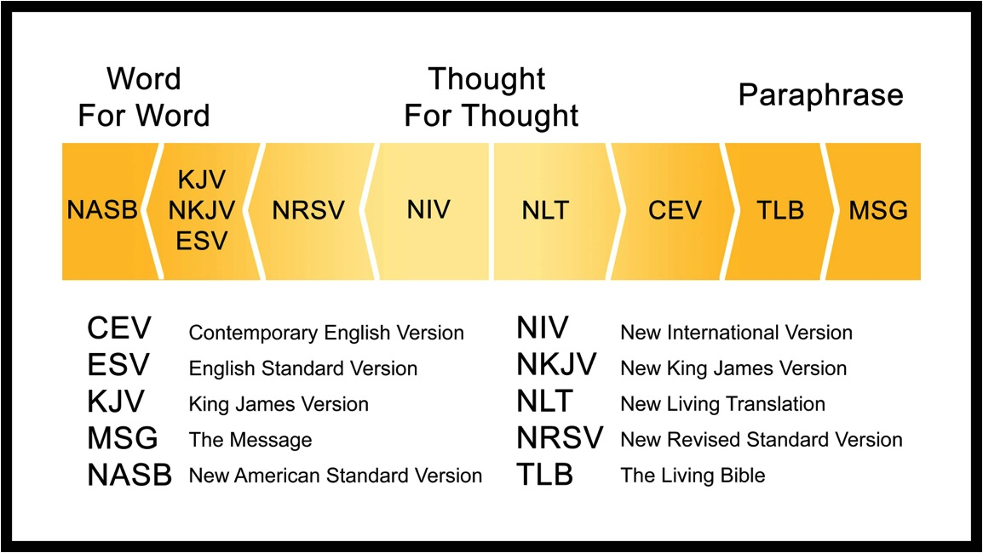
If you thought talking about the history of the English Bible was confusing, then talking about Greek and Hebrew manuscripts underlying translations throughout history is on another level entirely! As reflected in our English translations, there are variants in the Greek and Hebrew manuscripts in existence. This has been the case in the Hebrew texts we have, the Septuagint (LXX) and the earliest Greek manuscripts available. The debates on textual criticism (the practice of determining which manuscripts are closest to the original) are many, long, and complicated. Unless you know Greek and Hebrew, discussing it in this setting would be almost totally useless.
One “for instance” – Some hold to the position that the KJV is the best English Bible because the “Textus Receptus” is the best Greek text. The Textus Receptus is the group of manuscripts that the KJV is most closely associated with.
There are, however, not one “Textus Receptus,” but like the KJV, many revisions of it. It seems that most who hold consistently to this position prefer the “Scrivener” Textus Receptus. But again, like the 1611 KJV translators, Scrivener wrote a preface in his 1881 (notice, not 1611) edition of Greek text, and was not claiming infallibility of his work, but collated this text as a study tool for scholars to observe the selections most likely made by the KJV translators. You can read more about Scrivener and his work here:
The Preface To The Greek TR Of F.H.A. Scrivener | King James Bible History (kjbhistory.com)

A better position - The Greek and Hebrew manuscripts that contain the Bible that we have access to, the ones that have not been obviously tampered with, are excellent and worthy of our study! Study the Bible. Know God genuinely. Worship God Supremely. Serve others selflessly.
Translation Samples:
Ephesians 2:1-10
NASB
1 And you were dead in your trespasses and sins,
2 in which you formerly walked according to the course of this world, according to the prince of the power of the air, of the spirit that is now working in the sons of disobedience.
3 Among them we too all formerly lived in the lusts of our flesh, indulging the desires of the flesh and of the mind, and were by nature children of wrath, even as the rest.
4 But God, being rich in mercy, because of His great love with which He loved us,
5 even when we were dead in our transgressions, made us alive together with Christ (by grace you have been saved),
6 and raised us up with Him, and seated us with Him in the heavenly places in Christ Jesus,
7 so that in the ages to come He might show the surpassing riches of His grace in kindness toward us in Christ Jesus.
8 For by grace you have been saved through faith; and that not of yourselves, it is the gift of God;
9 not as a result of works, so that no one may boast.
10 For we are His workmanship, created in Christ Jesus for good works, which God prepared beforehand so that we would walk in them.

New American Standard Bible: 1995 Update (La Habra, CA: The Lockman Foundation, 1995), Eph 2:1–10.
CSB – the previous revisions of this were the HCSB/HCSV
2 And you were dead in your trespasses and sins 2 in which you previously walked according to the ways of this world, according to the ruler of the power of the air, the spirit now working in the disobedient. 3 We too all previously lived among them in our fleshly desires, carrying out the inclinations of our flesh and thoughts, and we were by nature children under wrath as the others were also. 4 But God, who is rich in mercy, because of his great love that he had for us, 5 made us alive with Christ even though we were dead in trespasses. You are saved by grace! 6 He also raised us up with him and seated us with him in the heavens in Christ Jesus, 7 so that in the coming ages he might display the immeasurable riches of his grace through his kindness to us in Christ Jesus. 8 For you are saved by grace through faith, and this is not from yourselves; it is God’s gift—9 not from works, so that no one can boast. 10 For we are his workmanship, created in Christ Jesus for good works, which God prepared ahead of time for us to do.
Christian Standard Bible (Nashville, TN: Holman Bible Publishers, 2020), Eph 2:1–10.

ESV
2 And you were dead in the trespasses and sins 2 in which you once walked, following the course of this world, following the prince of the power of the air, the spirit that is now at work in the sons of disobedience— 3 among whom we all once lived in the passions of our flesh, carrying out the desires of the body and the mind, and were by nature children of wrath, like the rest of mankind. 4 But God, being rich in mercy, because of the great love with which he loved us, 5 even when we were dead in our trespasses, made us alive together with Christ—by grace you have been saved— 6 and raised us up with him and seated us with him in the heavenly places in Christ Jesus, 7 so that in the coming ages he might show the immeasurable riches of his grace in kindness toward us in Christ Jesus. 8 For by grace you have been saved through faith. And this is not your own doing; it is the gift of God, 9 not a result of works, so that no one may boast. 10 For we are his workmanship, created in Christ Jesus for good works, which God prepared beforehand, that we should walk in them
The Holy Bible: English Standard Version (Wheaton, IL: Crossway Bibles, 2016), Eph 2:1–10.
NKJV
2 And you He made alive, who were dead in trespasses and sins, 2 in which you once walked according to the course of this world, according to the prince of the power of the air, the spirit who now works in the sons of disobedience, 3 among whom also we all once conducted ourselves in the lusts of our flesh, fulfilling the desires of the flesh and of the mind, and were by nature children of wrath, just as the others.
4 But God, who is rich in mercy, because of His great love with which He loved us, 5 even when we were dead in trespasses, made us alive together with Christ (by grace you have been saved), 6 and raised us up together, and made us sit together in the heavenly places in Christ Jesus, 7 that in the ages to come He might show the exceeding riches of His grace in His kindness toward us in Christ Jesus. 8 For by grace you have been saved through faith, and that not of yourselves; it is the gift of God, 9 not of works, lest anyone should boast. 10 For we are His workmanship, created in Christ Jesus for good works, which God prepared beforehand that we should walk in them.
The New King James Version (Nashville: Thomas Nelson, 1982), Eph 2:1–10. (The NKJV also generally leaves the text italicized in the same places the KJV does)
NIV
2 As for you, you were dead in your transgressions and sins, 2 in which you used to live when you followed the ways of this world and of the ruler of the kingdom of the air, the spirit who is now at work in those who are disobedient. 3 All of us also lived among them at one time, gratifying the cravings of our flesh and following its desires and thoughts. Like the rest, we were by nature deserving of wrath. 4 But because of his great love for us, God, who is rich in mercy, 5 made us alive with Christ even when we were dead in transgressions—it is by grace you have been saved. 6 And God raised us up with Christ and seated us with him in the heavenly realms in Christ Jesus, 7 in order that in the coming ages he might show the incomparable riches of his grace, expressed in his kindness to us in Christ Jesus. 8 For it is by grace you have been saved, through faith—and this is not from yourselves, it is the gift of God—9 not by works, so that no one can boast. 10 For we are God’s handiwork, created in Christ Jesus to do good works, which God prepared in advance for us to do.
The New International Version (Grand Rapids, MI: Zondervan, 2011), Eph 2:1–10.
NLT
Made Alive with Christ
Once you were dead because of your disobedience and your many sins. 2 You used to live in sin, just like the rest of the world, obeying the devil—the commander of the powers in the unseen world. He is the spirit at work in the hearts of those who refuse to obey God. 3 All of us used to live that way, following the passionate desires and inclinations of our sinful nature. By our very nature we were subject to God’s anger, just like everyone else.
4 But God is so rich in mercy, and he loved us so much, 5 that even though we were dead because of our sins, he gave us life when he raised Christ from the dead. (It is only by God’s grace that you have been saved!) 6 For he raised us from the dead along with Christ and seated us with him in the heavenly realms because we are united with Christ Jesus. 7 So God can point to us in all future ages as examples of the incredible wealth of his grace and kindness toward us, as shown in all he has done for us who are united with Christ Jesus.
8 God saved you by his grace when you believed. And you can’t take credit for this; it is a gift from God. 9 Salvation is not a reward for the good things we have done, so none of us can boast about it. 10 For we are God’s masterpiece. He has created us anew in Christ Jesus, so we can do the good things he planned for us long ago.
Tyndale House Publishers, Holy Bible: New Living Translation (Carol Stream, IL: Tyndale House Publishers, 2015), Eph 2:1–10.
TLB
2 Once you were under God’s curse, doomed forever for your sins. 2 You went along with the crowd and were just like all the others, full of sin, obeying Satan, the mighty prince of the power of the air, who is at work right now in the hearts of those who are against the Lord. 3 All of us used to be just as they are, our lives expressing the evil within us, doing every wicked thing that our passions or our evil thoughts might lead us into. We started out bad, being born with evil natures, and were under God’s anger just like everyone else.4 But God is so rich in mercy; he loved us so much 5 that even though we were spiritually dead and doomed by our sins, he gave us back our lives again[a] when he raised Christ from the dead—only by his undeserved favor have we ever been saved— 6 and lifted us up from the grave into glory along with Christ, where we sit with him in the heavenly realms—all because of what Christ Jesus did. 7 And now God can always point to us as examples of how very, very rich his kindness is, as shown in all he has done for us through Jesus Christ.
8 Because of his kindness, you have been saved through trusting Christ. And even trusting is not of yourselves;[b] it too is a gift from God. 9 Salvation is not a reward for the good we have done, so none of us can take any credit for it. 10 It is God himself who has made us what we are and given us new lives from Christ Jesus; and long ages ago he planned that we should spend these lives in helping others.
The Living Bible - https://www.biblegateway.com/passage/?search=Ephesians+2&version=TLB
The Message (Notice how this is even “paragraphed” instead of “versed” together.) Eugene Peterson’s goal for what he calls a translation (I have an issue with how he defines translation, but we’re not defining the word the same way) was to state the “big idea” in the most casual English way possible
1–6 2 It wasn’t so long ago that you were mired in that old stagnant life of sin. You let the world, which doesn’t know the first thing about living, tell you how to live. You filled your lungs with polluted unbelief, and then exhaled disobedience. We all did it, all of us doing what we felt like doing, when we felt like doing it, all of us in the same boat. It’s a wonder God didn’t lose his temper and do away with the whole lot of us. Instead, immense in mercy and with an incredible love, he embraced us. He took our sin-dead lives and made us alive in Christ. He did all this on his own, with no help from us! Then he picked us up and set us down in highest heaven in company with Jesus, our Messiah.
7–10 Now God has us where he wants us, with all the time in this world and the next to shower grace and kindness upon us in Christ Jesus. Saving is all his idea, and all his work. All we do is trust him enough to let him do it. It’s God’s gift from start to finish! We don’t play the major role. If we did, we’d probably go around bragging that we’d done the whole thing! No, we neither make nor save ourselves. God does both the making and saving. He creates each of us by Christ Jesus to join him in the work he does, the good work he has gotten ready for us to do, work we had better be doing.
Eugene H. Peterson, The Message: The Bible in Contemporary Language (Colorado Springs, CO: NavPress, 2005), Eph 2:1–10.
Translations to avoid:
NWT – The New World translation. Jehovah’s Witnesses have intentionally removed terminology that refers to the deity of Christ.
The Passion Translation – Brian Simmons made the claim that the Holy Spirit told him the words to choose and write. Honest translators don’t do this.
The Cotton Patch, Word on the Street, etc. – “This guy John was dressed in blue jeans and a leather jacket, and he was living on corn bread and collard greens. Folks were coming to him from Atlanta and all over north Georgia and the backwater of the Chattahoochee. And as they owned up to their crooked ways, he dipped them in the Chattahoochee. -- Matthew 3:4-6” – A much too casual; inaccuracies of various sorts.
New American Bible/Douai Rheims – Slanted Catholic theology
Gender-neutral Bibles – use caution here. Some say it is better to say “humankind” instead of “mankind” in modern English. That argument can be made, but the Hebrew really does read more like “mankind” even though humankind is what mankind refers to. Other works blatantly promote secular feminism (changing male characters to female, etc.): thefeministbible.com/about
Good popular translations in no particular order: KJV, NASB, NKJV, ESV, CSB

This is not the same thing as higher criticism – which critiques the Bible’s historicity and calls into question anything miraculous found in the Bible.
There are also positions that favor the “eclectic text,” “majority text,” and the “byzantine text.” Study on this subject is long, dry, and complicated. But if anyone is truly interested in this endeavor of study, I suggest starting by mastering Koine Greek and Hebrew.
There was a recent translation produced (The Modern English Version – MEV) that has kept all the underlying Greek and Hebrew text of the KJV, but has replaced KJV-isms with their modern equivalents.

