How We Got the Bible
Lesson 3 - Copies of Greek and Hebrew Manuscripts in Existence
Book recommendation: “From the Mind of God to the Mind of Man”
- The numbers have been conflated over time and have changed over time! We can, however, be honest about what we have and what exists. Most people have never seen what is called a “biblical manuscript,” but you can find pictures online for free at The Center for the Study of New Testament Manuscripts (csntm.org)
What people used for writing during biblical days depended on the degree of importance.
Tablets – a hollowed out board filled with wax that could be smoothed out repeatedly (Potentially Zacharias wrote on something like this that his son’s name would be John).
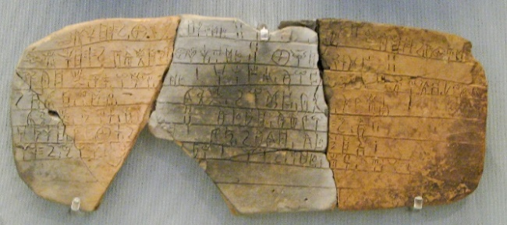
Letters to friends – flat stone, smooth board, or broken piece of pottery
Papyrus – this is where we get the word paper
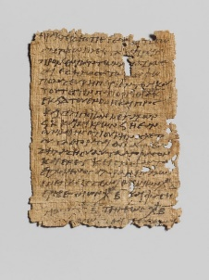
They still make papyri, so you can buy a fresh sheet if you’re interested! $12 a sheet.

Parchment was also made in sheets, but from animal skins, so it was more expensive.
(II Tim. 4:13)
Scrolls and Codices
One could make scrolls from either parchment or papyri, by sewing the leaves together like a rough book called a codex. We have codices by the time of the 2nd Century, AD.
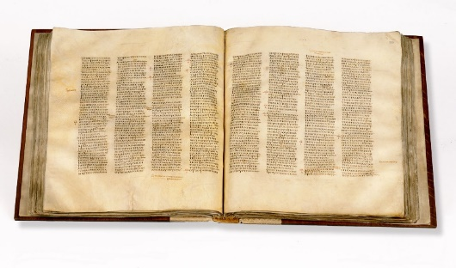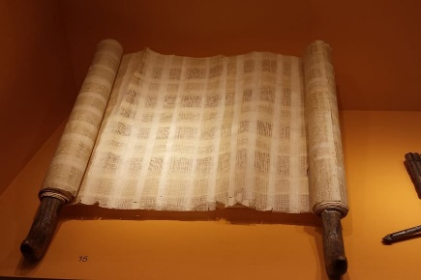
Codex Sinaiticus Scroll
Generally, when we’re discussing papyri, we’re talking about the earliest New Testament manuscripts in existence. Many of these are stored in museums, colleges, monasteries, and seminaries all over the world, and doubtless some have yet to be discovered.
The oldest known copy of the Torah: https://www.usatoday.com/story/news/2016/09/21/burnt-manuscript-one-oldest-known-copies-torah-ever-found/90786164/
Seriously, go watch this video! ^
Today, you can go online and look at the oldest known copy of Isaiah also called “The Great Isaiah Scroll,” dating to hundreds of years before Jesus ever walked the face of the earth!
http://dss.collections.imj.org.il/isaiah#2:8

Go to the website link just given and navigate in the Isaiah scroll to Isaiah 53:6. I’ve included the verse from a modern Hebrew Bible below. Compare and count the letters between this modern Hebrew Bible and the Great Isaiah scroll (dated to about 125 BC—over 100 years before Jesus ever walked the earth!)

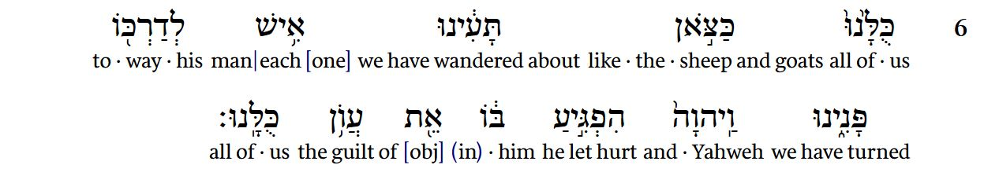

Kinds of manuscripts: Papyri (OLD, VERY OLD), majescules (OLD, big letters), and miniscules (old, small cursive letters)
Here is where an early church father quotes from Scripture
Philippians 2:5–8.
“Have this mind in you, which was also in Christ Jesus: who, being in the form of God, counted it not a prize to be on an equality with God, but emptied Himself, taking the form of a servant, being made in the likeness of men; and being found in fashion as a man, He humbled Himself, becoming obedient even unto death, yea, the death of the cross.”
Our Lord Jesus Christ, when exhorting His disciples to great actions, places before them Himself, and the Father, and the Prophets, as examples; as when He says, “For thus they did unto the Prophets which were before you” (Matt. 5:12; Luke 6:23); and again, “If they persecuted Me, they will also persecute you” (John 15:20); and, “Learn of me, for I am meek” (Matt. 11:29); and again, “Be ye merciful, as your Father which is in heaven is merciful.” (Luke 6:36.) This too the blessed Paul did; in exhorting them to humility, he brought forward Christ.
Notice how the translated quote from Chrysostom might not match “word for word” to the English Bible translation you own.

The Latin Vulgate – a 4th century Latin translation of the Bible (300’s), pictured below is an 8th century revision.
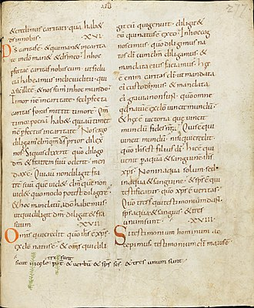

(Interesting detail: That’s 1 John 5:7 written in the bottom margin, not in the text. The oldest Greek manuscript containing 1 John 5:7 was back-translated from a Latin one. This is problematic for those that would say this verse is original as the scriptures were originally penned in Greek. For further information on this subject look up articles by Daniel Wallace.)
How can they tell how old manuscripts are?
Archaeologists and scholars can look at the kind of papyrus, parchment, ink, binding, text divisions, order of books, or handwriting used.
God used a number of surprising ways to preserve the manuscripts we have today. What we have is due to many factors including, but not limited to, the crusades, monasteries, the Greek Orthodox Church, the Roman Catholic Church, libraries, wealthy citizens, ambassadors, and czars.
What does the OT say about itself?
- “But there are many other examples, such as the speech by God to Adam and Eve both before and after the Fall (Gen. 1:28–30; 3:9–19), the call of Abram (Gen. 12:1–3), subsequent lengthy conversations with Abram in which God’s covenantal provisions are established (Gen. 15:1–21; 17:1–21; note also Abraham’s remarkable conversation with the Lord in Gen. 18:1–23), the extensive dialogue between God and Moses at the burning bush (Exod. 3:1–4:23), the revelation to Samuel concerning the doom of Eli’s house (1 Sam. 3:10–14), the conversation with Elijah at Mount Horeb (1 Kings 19:9–18), God’s detailed (and poetic) response to Job (Job 38–41), and frequent conversations between God and the prophets (Isa. 6:8–13; Jonah 1:1–2; 3:1–2; 4:1–11, et al.). In addition, large sections of the legal code found in the Pentateuch are represented as words spoken directly by God to Moses (see, for example, Exod. 20:22–23:33).”
- “Second, these passages never view human language as a barrier to effective communication by God. There is no hint that some inadequacies inherent in human language may be used as a legitimate reason to disbelieve or to disobey anything God has said. The appropriate response, according to the Old Testament writers, is, ‘All the words which the Lord has spoken we will do’ (Exod. 24:3). Similarly, Abram’s belief in God’s seemingly impossible promises is commended: ‘And he believed the Lord; and he reckoned it to him as righteousness’ (Gen. 15:6).” [emphasis mine]
What does the NT say about its own writings and the Bible?
- 2 Peter 1:21, John 1 – Logos, God communicating to Man
- Jesus’ NT “It is written” – quoting the OT. Here, Jesus’ quotations do not match up exactly with the English KJV or the Greek LXX. That does not conflict with what God has done in translation ever since Genesis.
- KJV, Jesus in Matt. 4:4 “But he answered and said, It is written, Man shall not live by bread alone, but by every word that proceedeth out of the mouth of God.”
- KJV, what Deut. 8:3 actually says, “And he humbled thee, and suffered thee to hunger, and fed thee with manna, which thou knewest not, neither did thy fathers know; that he might make thee know that man doth not live by bread only, but by every word that proceedeth out of the mouth of the LORD doth man live.”
Was Jesus “watering down” the message of Deut. 8:3? Absolutely not. Rather, this reflects how translation has always worked. One passage is translated from Hebrew, the other—Jesus’ quotation—comes from the LXX. This is why the translations are “different.”
Adding/Taking Away and Apostleship
- 2 Timothy 1:1 (Paul’s Apostleship)
- Revelation 22:18-19
- James “to the 12 tribes scattered abroad.”
- Paul wrote his letters and said, “See that this is read in all the churches.”
When we’re talking about adding/taking away from God’s Word, we shouldn’t claim that the KJV translators will face dire consequences (God forbid!), because they put the name of God in Romans 6:2 where it does not belong, or even other more minor language challenges, such as the extra words in Hebrew and Greek that just don’t have an equivalent in English, 1611 nor modern. Do we need the same number of words? No, otherwise translation itself would be sinful. But we need the same truth. We need the intended meaning and commands and principles that God intended to communicate.
What happened in early church history with the Bible?
In overly-simplistic summary, the very early stages of biblical preservation in the first 300 years AD, Christians would have been hearing (very few would have been reading) the Bible in their various churches in cities and countries across the known world.

Greek-Speak
In some Jewish communities, they would not have read the OT in Hebrew, but Greek during this time period due to the influence of Alexander the Great (massive military campaigns from stretching from Western Asia to Northeastern Africa). Greek was the international trade language, so most Christians were reading Old and New Testaments using the Septuagint (LXX) translation of the Bible for the old, and this is also why the NT was originally written In Greek. The manuscripts are of course reflective of that fact.
When the NT quotes the OT, the majority of the time, the quotes come directly from the LXX (Septuagint) - the most familiar OT translation to the people of Jesus’ day. This gives us insight as to how God views translation, as the LXX has certain phrases that are not in total agreement even by translation standards to the Hebrew Masoretic text, but there is nothing unsettling here in regard to serious doctrinal matters. The LXX was a trustworthy translation (even to Jesus and the apostles!), even though it was known to not be an exact copy or a “perfect” translation. It could have been better. Jerome (the translator of the Latin Vulgate), the KJV translators (who famously said that “even the very meanest” translation of God’s Word not only contains it, but is the Word of God), and modern Bible translators all view the LXX in this light.
It was an excellent translation that reflected the original language but in the modern tongue. It could have been better. Even so, God’s truth was not compromised. The same can be said of portions of the NT that we know were not originally spoken in Greek, but are preserved for us via Greek translation (and now, thankfully, understandable even for us today in English!).
The Latin Vulgate
Hearing the Bible read in Greek dominates the first 300+ years until the completion of the Latin Vulgate. Jerome of Stridon was commissioned by Pope Damasus I to complete this work in the late 300’s. This Bible was officially instated as the Catholic Bible as the Sixtine Vulgate in 1590, followed by a revision in the Clementine Vulgate in 1592. The most recent Latin Vulgate (Nova Vulgata) is from 1979.
So, for the first few hundred years of Christianity, there is not much discussion of translation because people were hearing the Bible read in Greek, followed by sermons preached in Greek (the spoken language). Latin enters the scene in the late 300’s.
God’s truth endures to every generation. KEY TAKEAWAYS
- God communicated in various ways in the Old Testament and finally in the written OT.
- God then revealed Jesus Christ as the Word. Jesus the Messiah, full of grace and truth.
- Jesus spoke to the apostles, who, prior to the completion of the New Testament, told to churches precisely what Jesus told them.
- In a similar way to the OT, God worked in some of those apostles to write Scripture, which would then be read in churches and recognized as God’s Holy Word.
- We could say to the Greek speaking people reading their Greek Old Testaments, even though the OT was written in Greek, and even though many of those handwritten copies differed occasionally in wording or spelling—indeed, not one pair of ancient manuscripts in existence are exactly alike, and we saw why this was not a problem in our very first lesson together —yet God’s truth has been preserved to every generation.
- God’s Word was not developing in the years 100-200, it was complete, and wholly the Word of God, and the people who heard a particular copy of a particular read in their local church in the year 175, for example, could rest knowing that God’s Word was trustworthy—centuries before the English language was even a thought. But the Word of God in their generation, various hand-copied Greek manuscripts, needed to be studied and received.
- You have been charged by God to put forth the effort to know His Word. “Study [meaning, be diligent] to show yourself approved a workman . . .”
- Be thankful for the work of copyists and translators that God used over thousands of years that now you have a Bible in your hands that you can understand and study.
- Our very faith in God comes by hearing and receiving its truth (Romans 10:17).

Ed. James B. Williams
Accessed March 18, 2023
John Chrysostom. (1889). Homilies of St. John Chrysostom, Archbishop of Constantinople, on the Epistle of St. Paul the Apostle to the Philippians. In P. Schaff (Ed.), W. C. Cotton & J. A. Broadus (Trans.), Saint Chrysostom: Homilies on Galatians, Ephesians, Philippians, Colossians, Thessalonians, Timothy, Titus, and Philemon (Vol. 13, p. 206). New York: Christian Literature Company.
John C. Mincy in God’s Word in Our Hands pg. 123.
God’s Word in Our Hands pg. 149
Carson, D. A., & Woodbridge, J. D. (1992). Scripture and Truth (pp. 19–20). Grand Rapids, MI: Baker Book House.
Carson, D. A., & Woodbridge, J. D. (1992). Scripture and Truth (p. 20). Grand Rapids, MI: Baker Book House.

